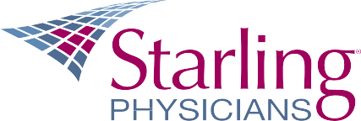
Sponsorship Request Form
Please complete this form if you would like to request corporate funding and/or marketing support for a department sponsorship. Please include any supporting documentation about the sponsorship, if available. Requests will be reviewed by Marketing Committee. Please make a request several weeks prior to an event.
Completed forms can be sent to Dawn Saling at: dsaling@starlingphysicians.com.
Department:
Requester:
Date:

What is the event or organization your department would like to sponsor*?

Please indicate the timing for this sponsorship (i.e. day, season, year)

When is decision needed on sponsorship?

Why do you believe this is a worthwhile sponsorship?

What sponsorship amount are you requesting? What is included at this sponsorship amount?

Are members of your department planning to be involved (form a team, have a booth, etc.)?

Has Starling and/or your department sponsored this event before?

What type of marketing support would you require (e.g. ads, giveaway, banner)?

Would you be able to share photos and/or videos of Starling’s participation in this sponsorship?

Other information you would like to add:

